**Fire Safety Advice for Contract Holders** 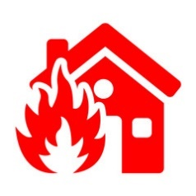

Smoke and heat alarms save lives. They provide early warning of a fire and allow you to make your escape – but only if they are working. For the best protection, smoke alarms should be provided in every room, including bedrooms and the lounge, and a heat detector in your kitchen.

*Please contact customer service team on 0800 024 8968 or please consider emailing us at* [*enquiries@hafod.org.uk*](mailto:enquiries@hafod.org.uk) *or using the Hafod 24/7 app, if you have any concerns.*

This leaflet provides fire safety guidance to keep yourself and others safe from fire. Further advice on fire safety in the home can be found on <https://www.southwales-fire.gov.uk/your-safety-wellbeing/at-home/>

You can prevent fire from happening by taking a few simple steps:

* Never leave cooking unattended – keep an eye on your cooker when it is on.
* Deep fat fryers or oven chips are much safer than using open chip pans. If you use a chip pan, do not fill it up too much (no more than 1/3 full).
* Make sure cigarettes are put out properly in a sturdy ashtray.
* Don’t smoke in a chair if you have been drinking alcohol or feel sleepy.
* Do not smoke when sleepy or in bed.
* Keep lighters and matches away from children.
* Do not overload electrical sockets by plugging in too many electrical appliances.
* Turn electrical appliances off at the wall, this is safer than leaving them on standby.
* Don’t leave appliances on when sleeping or out of the house – this includes washing machines, dishwashers and tumble dryers.
* Avoid the use of candles - if you must use them, make sure candles are secured in a holder and away from materials that may catch fire, like curtains - children must never be left alone with lit candles.
* Do not use oil/paraffin burners.
* Take care if you use portable heaters. Don’t dry clothes over them or otherwise obstruct them.
* If you use an electric blanket, make sure it is in good condition. Only use blankets that bear the BEAB certification mark. Do not use blankets that are more than 10 years old or that show signs of wear. Arrange for the blanket to be checked by a specialist every 3 years or as recommended by the manufacturer. Moth proofing chemicals should not be used or heavy items placed on top. Blankets should not be folded as this can damage the wiring. They may be left on beds or loosely rolled up and stored in a cool, dry place.
* If you have a mobility scooter, follow the guidance from Hafod as to where it can be stored and charged. If you need to keep it in your own accommodation, this should be agreed with Hafod in advance and make sure you don’t leave it where it will stop you getting out quickly in an emergency.
* Do not take into the home, anything which is of a flammable nature that might explode or be a fire hazard such as bottled gas and/or paraffin.
* Do not replace doors within the property without permission from Hafod.
* If you require oxygen therapy, follow the guidance you are given on using this safely. Never smoke when using oxygen.

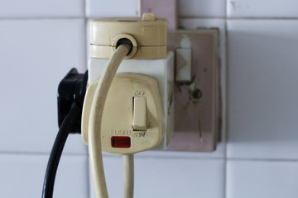 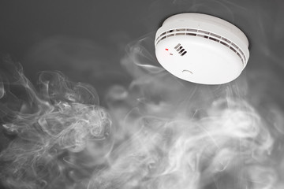

**Have a bedtime checklist**

You are more at risk from a fire when asleep, so it’s a good idea to check your home before you go to bed.

* Close internal doors at night to stop a fire from spreading
* Turn off and unplug electrical appliances unless they are designed to be left on – like your freezer. Check your cooker is turned off
* Don’t leave the washing machine on
* Turn heaters off and put-up fire guards
* Put cigarettes out properly
* Make sure exits are kept clear
* Keep door and window keys where everyone can find them

 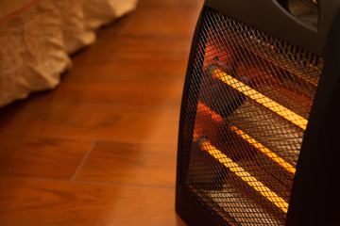

**Keep safe and plan your escape**

Flats are designed to resist the spread of fire. Because of this, a fire is not likely to spread from one flat to another. The flat entry door is a fire door and is fitted with a self-closing device. It is important that the self-closer works correctly to make sure a fire does not spread from one flat to another.

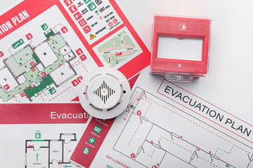

If your building operates a ‘stay put’ policy and there is a fire in your building – but not in your flat – you should stay in your home and keep the front door closed unless:

* You are directly affected by heat, smoke or fire.
* Or the Fire and Rescue Service or Police tells you to get out.

Follow the instructions on the fire action notices. Take time to read them, so that you know what to do if there is a fire or the fire alarm sounds.

If the fire is where you are – in your home or in a common area – leave the building immediately if it is safe to do so and call the Fire and Rescue Service on 999. Tell other residents if you can, but don’t put yourself at risk.

If you are in the common parts and you hear the fire alarm sounding, leave the building. Do not return to your flat. If the building is fitted with a fire alarm system, operate a fire alarm call point on your way out.

Your stairway should be safe for escape throughout the course of a fire. Use the stairs to get down to the ground floor – never take the lift.

There will be a marked fire assembly point where you should wait until you receive instructions from the fire brigade. Do not re-enter the building until you are told it is safe by the Fire brigade in attendance.

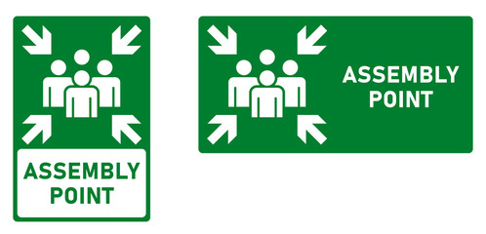

It is rare for people to be trapped by fire. If you are:

* Go to a “safe room” which should have a window and a phone.
* Call the Fire and Rescue Service and pack bedding or towels around the door to keep out smoke.
* Open the window to breathe clean air and try attracting attention by waving a sheet if it is safe to do so.

**Once you get out, call the Fire and Rescue Service and stay out.**

**Key things to remember:**

* Plan an escape route out of your home and keep it clear so you can leave quickly if you have to.
* Make sure you’ve got working smoke and heat alarms and test them weekly.
* At the end of the day, check cookers and electrical appliances are switched off and cigarettes are extinguished.
* Close all doors when you go to bed - especially the doors to the lounge and kitchen.
* If your clothes catch fire ‘stop, drop and roll’.

**Assist Hafod in keeping you and others safe from fire:**

Follow the advice in preventing fires in your accommodation and elsewhere in the building and in avoiding false alarms from smoke alarms that disrupt you and others. In particular:

* Do not interfere with the fire alarm system.
* Make sure stairs, landings and corridors are clear for escape. Never leave your belongings or rubbish in stairs, landings or corridors.
* Provide information when requested so that South Wales Fire & Rescue Service can be advised of those with mobility issues/using oxygen.
* Do not wedge open fire doors. If you see a fire door that is not closing or is damaged, let Hafod know.
* Follow restrictions that may apply to what you can store and use in your accommodation as part of your occupation contract.
* If you have any questions, you should speak to your neighbourhood coach for fire safety in your building.

